# NAME: ITALIYA NIRAJKUMAR VIJAYBHAI ENROLLMENT NO.:- 190130107041

**SUBJECT:- COMPUTER NETWORKS (3150710) BATCH:- CE-A2**

**FACULTY:- PROF. NIRANJAN PRAJAPATI**

## Practical-1:- Study of different network devices in detail Repeater, Hub, Network Bridge, Switch, Router, Gateway, Brouter

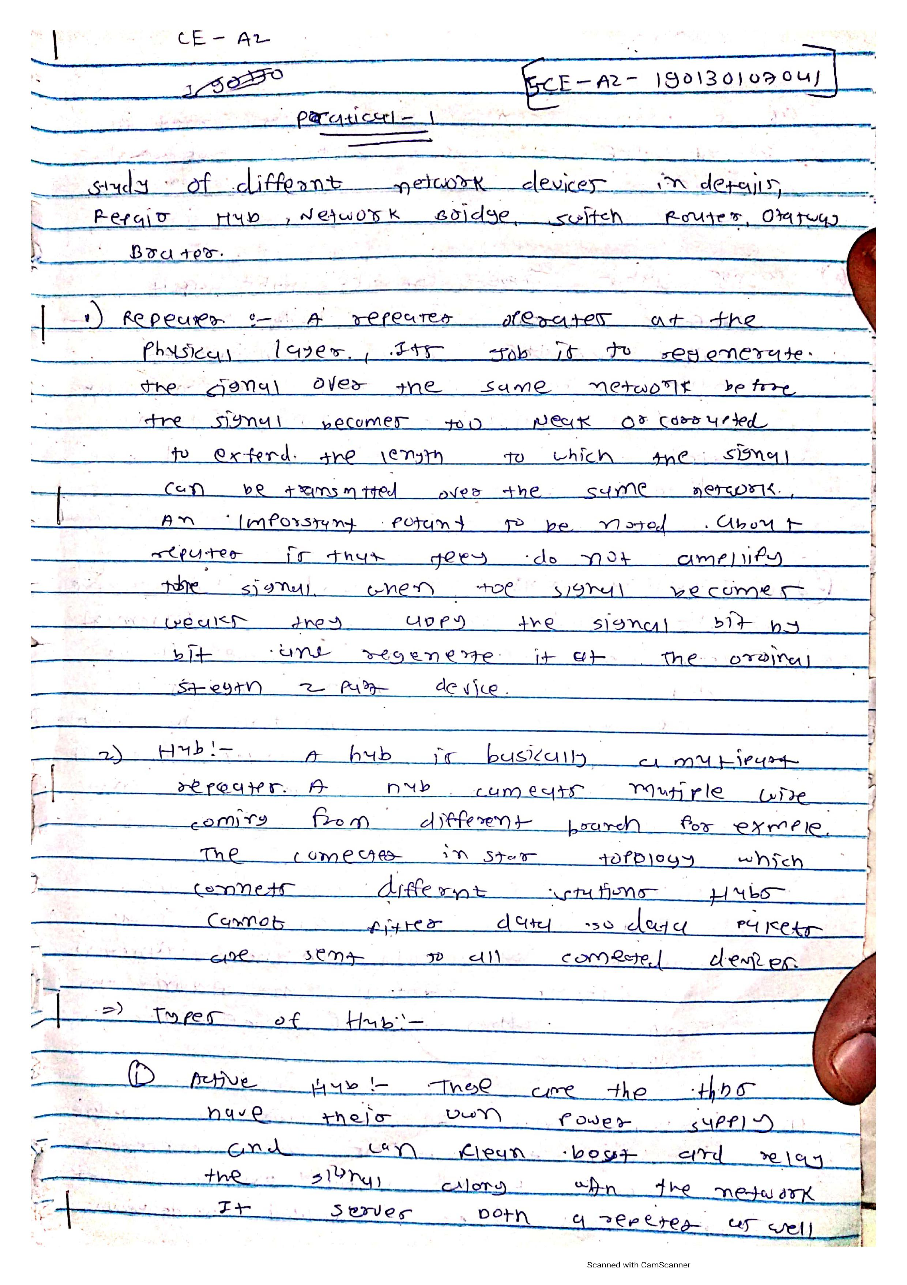

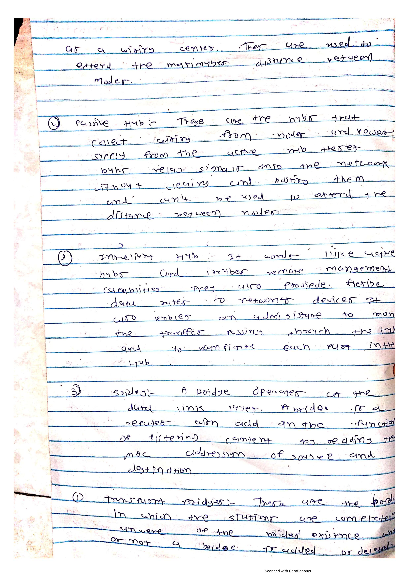

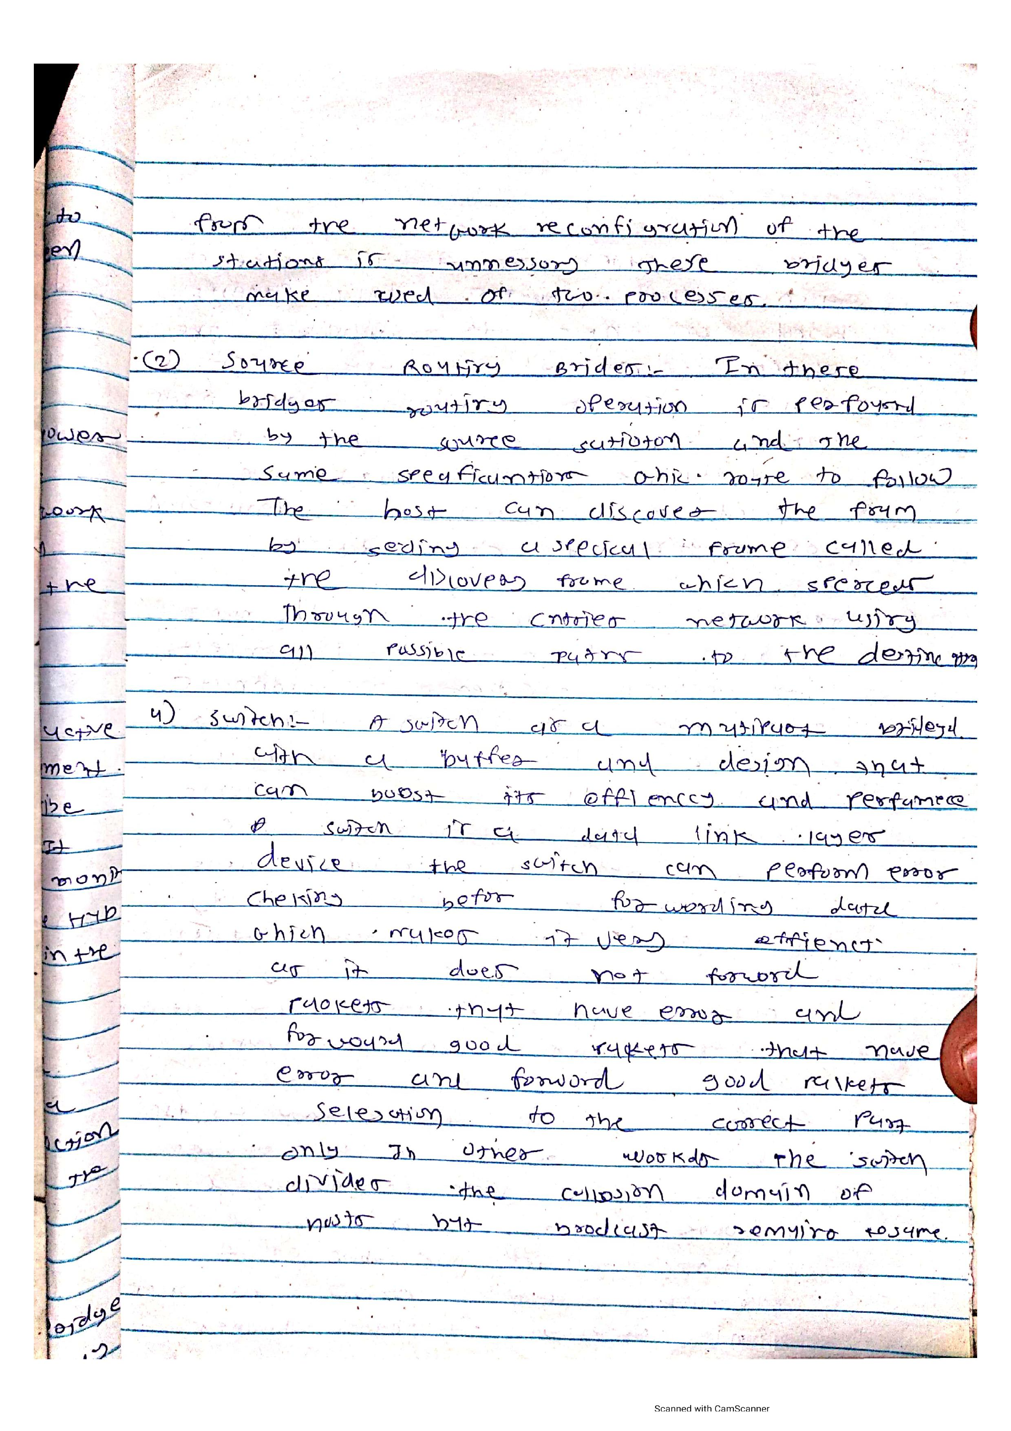

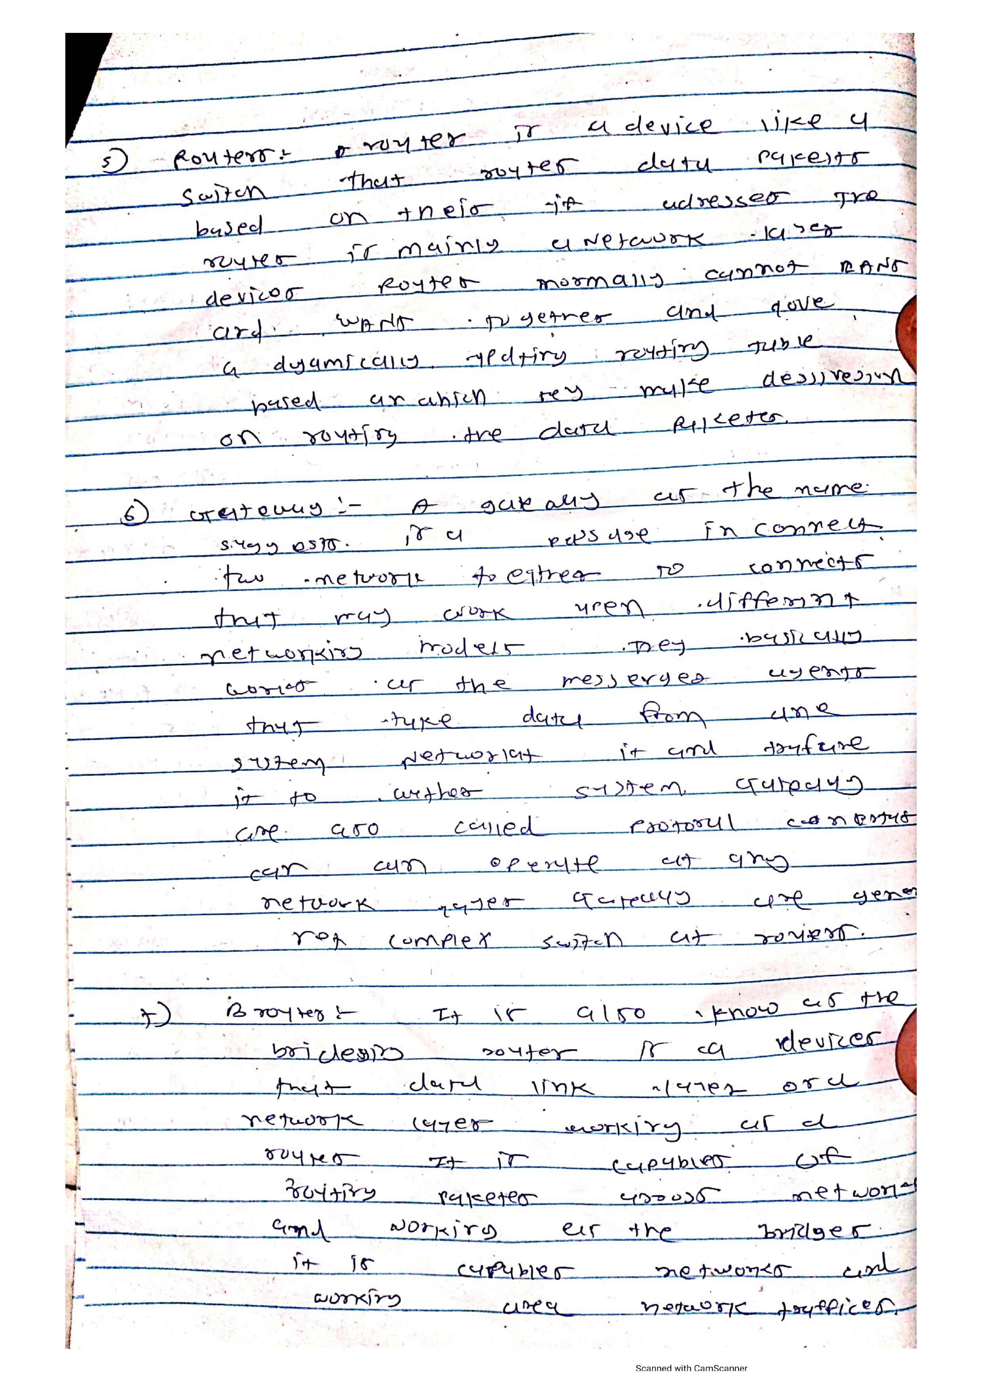

**Practical-2:- Study of basic network commands and configurations in detail Ifconfig|ipconfig, ping, tracert|traceroute, netstat**

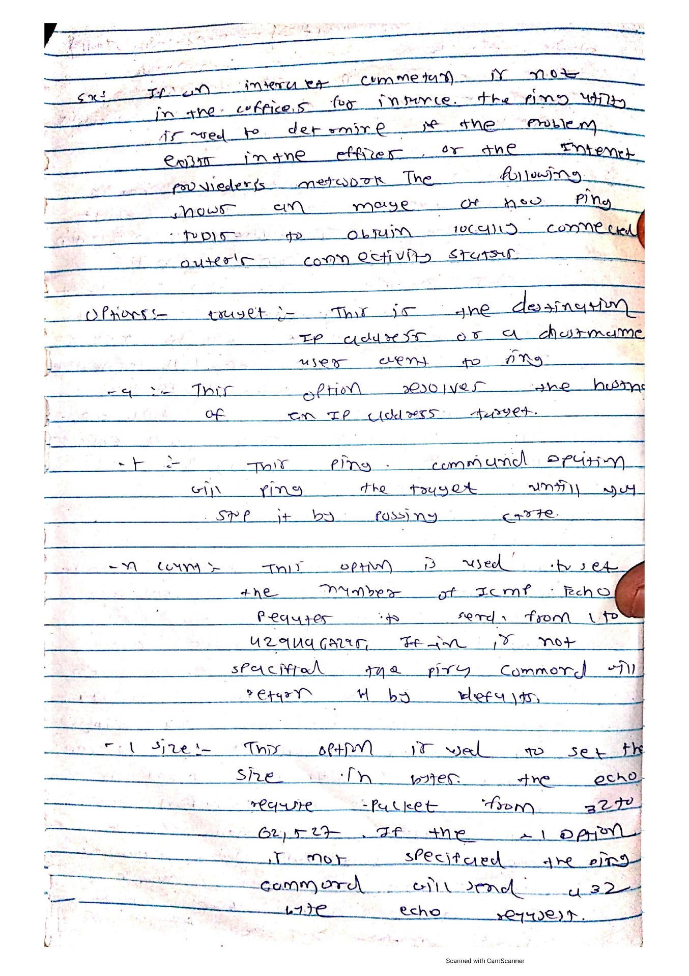

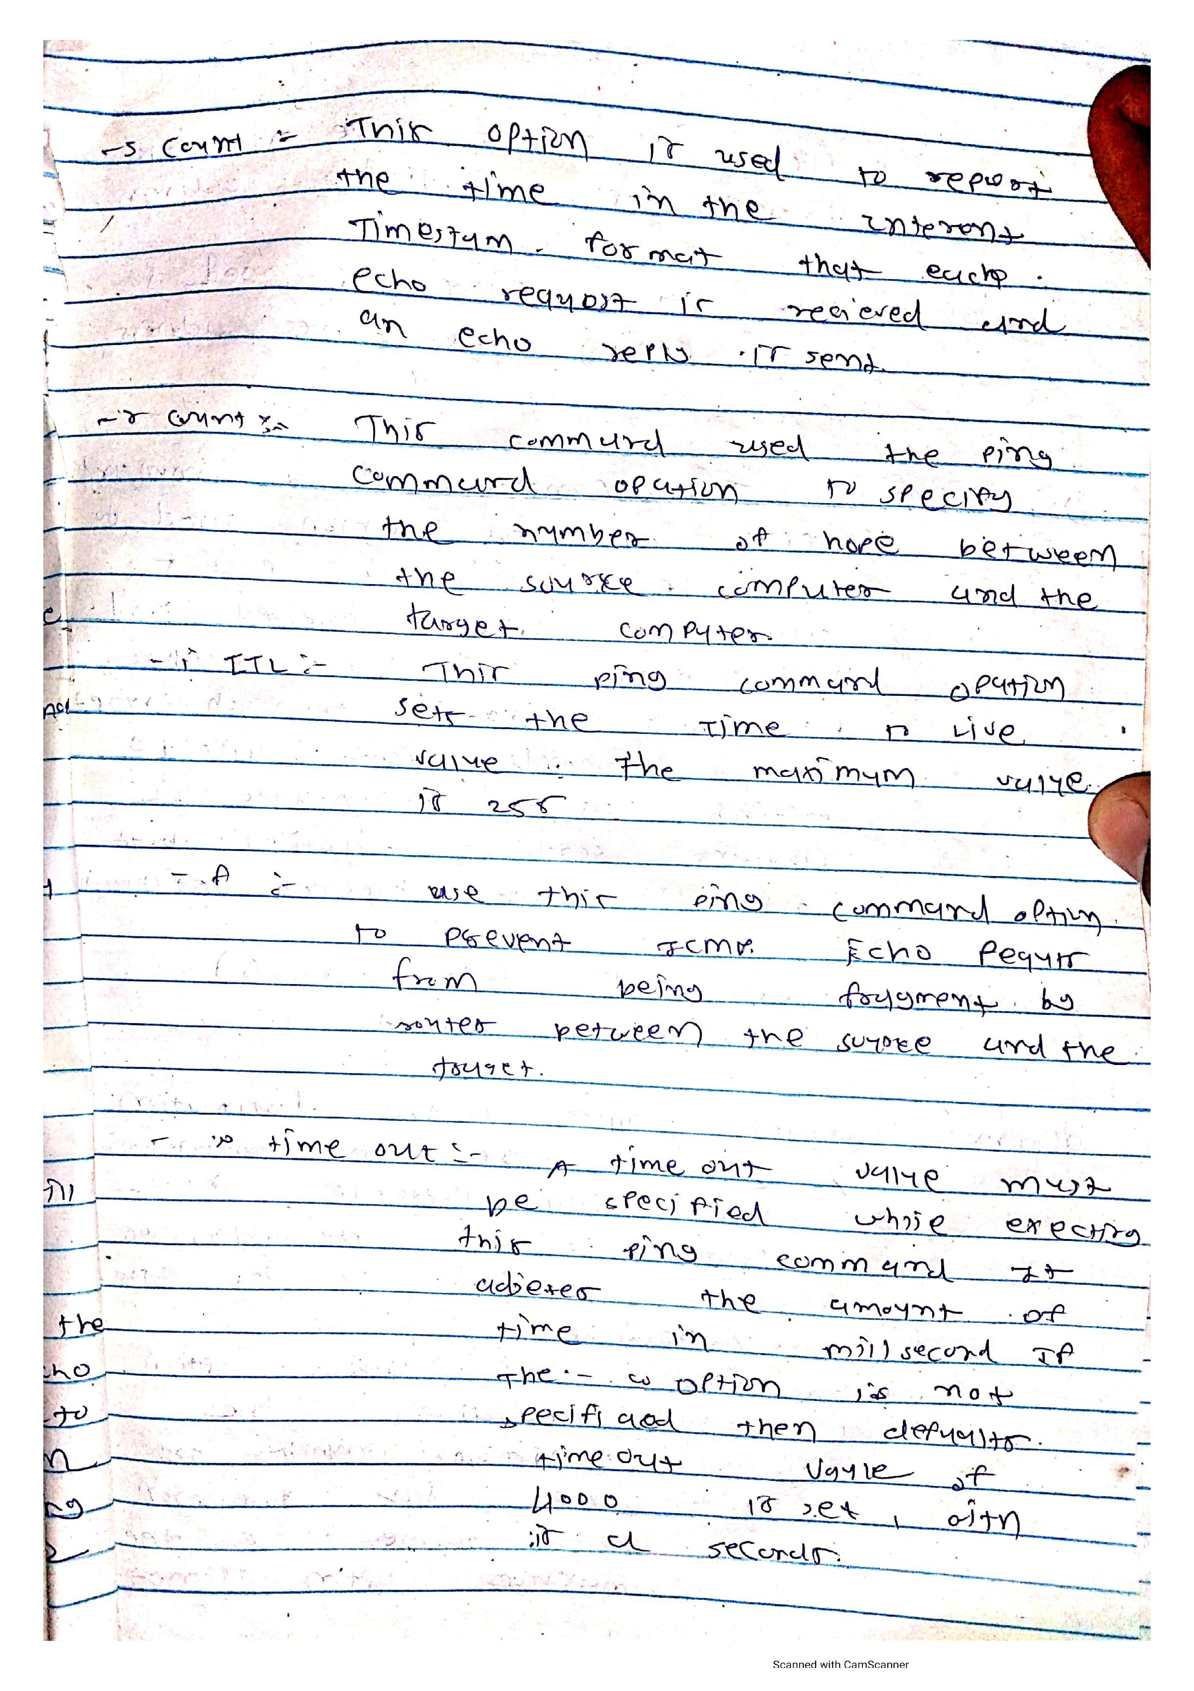

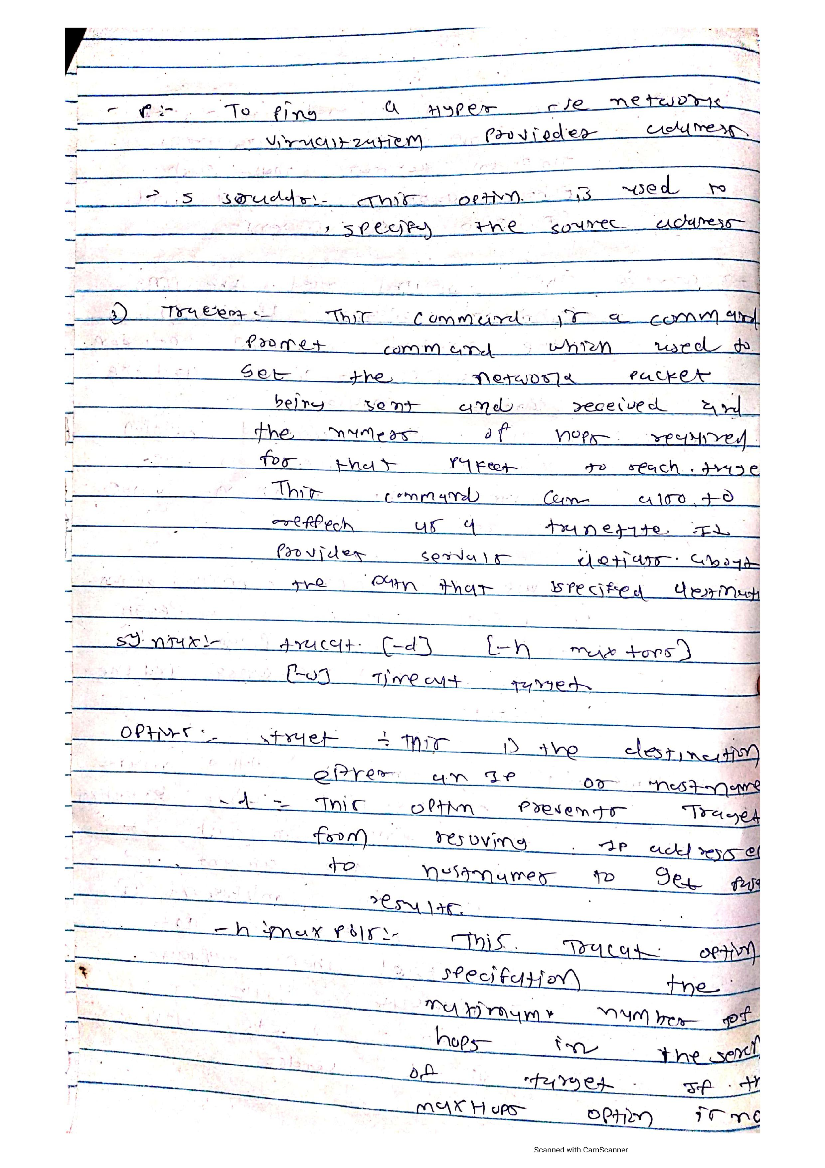

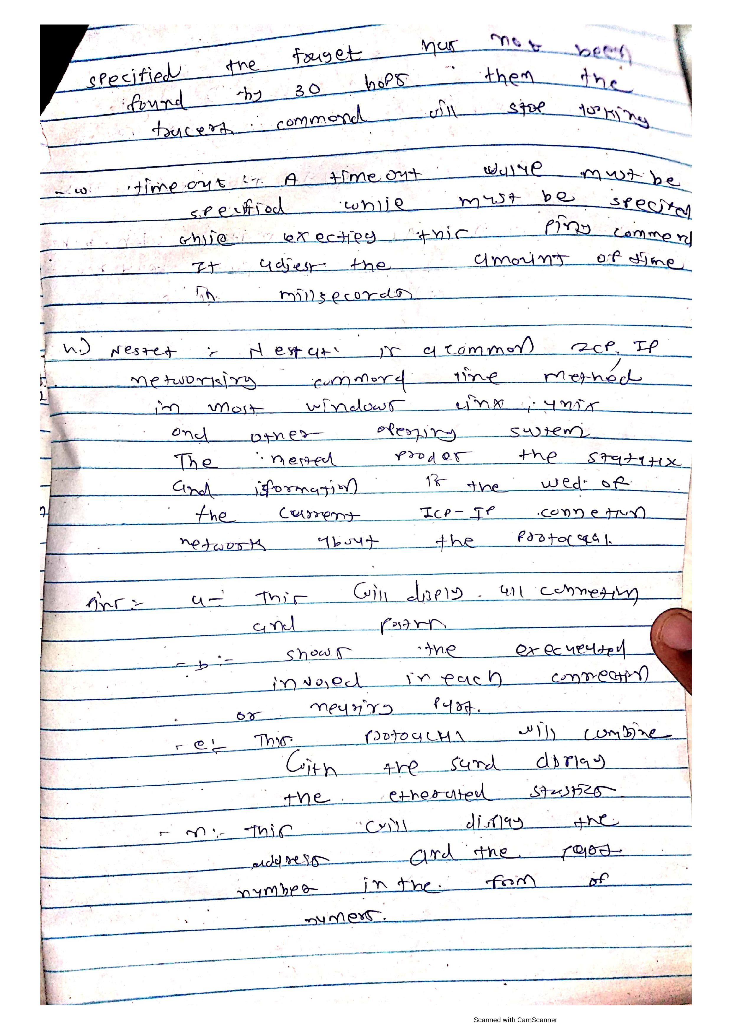

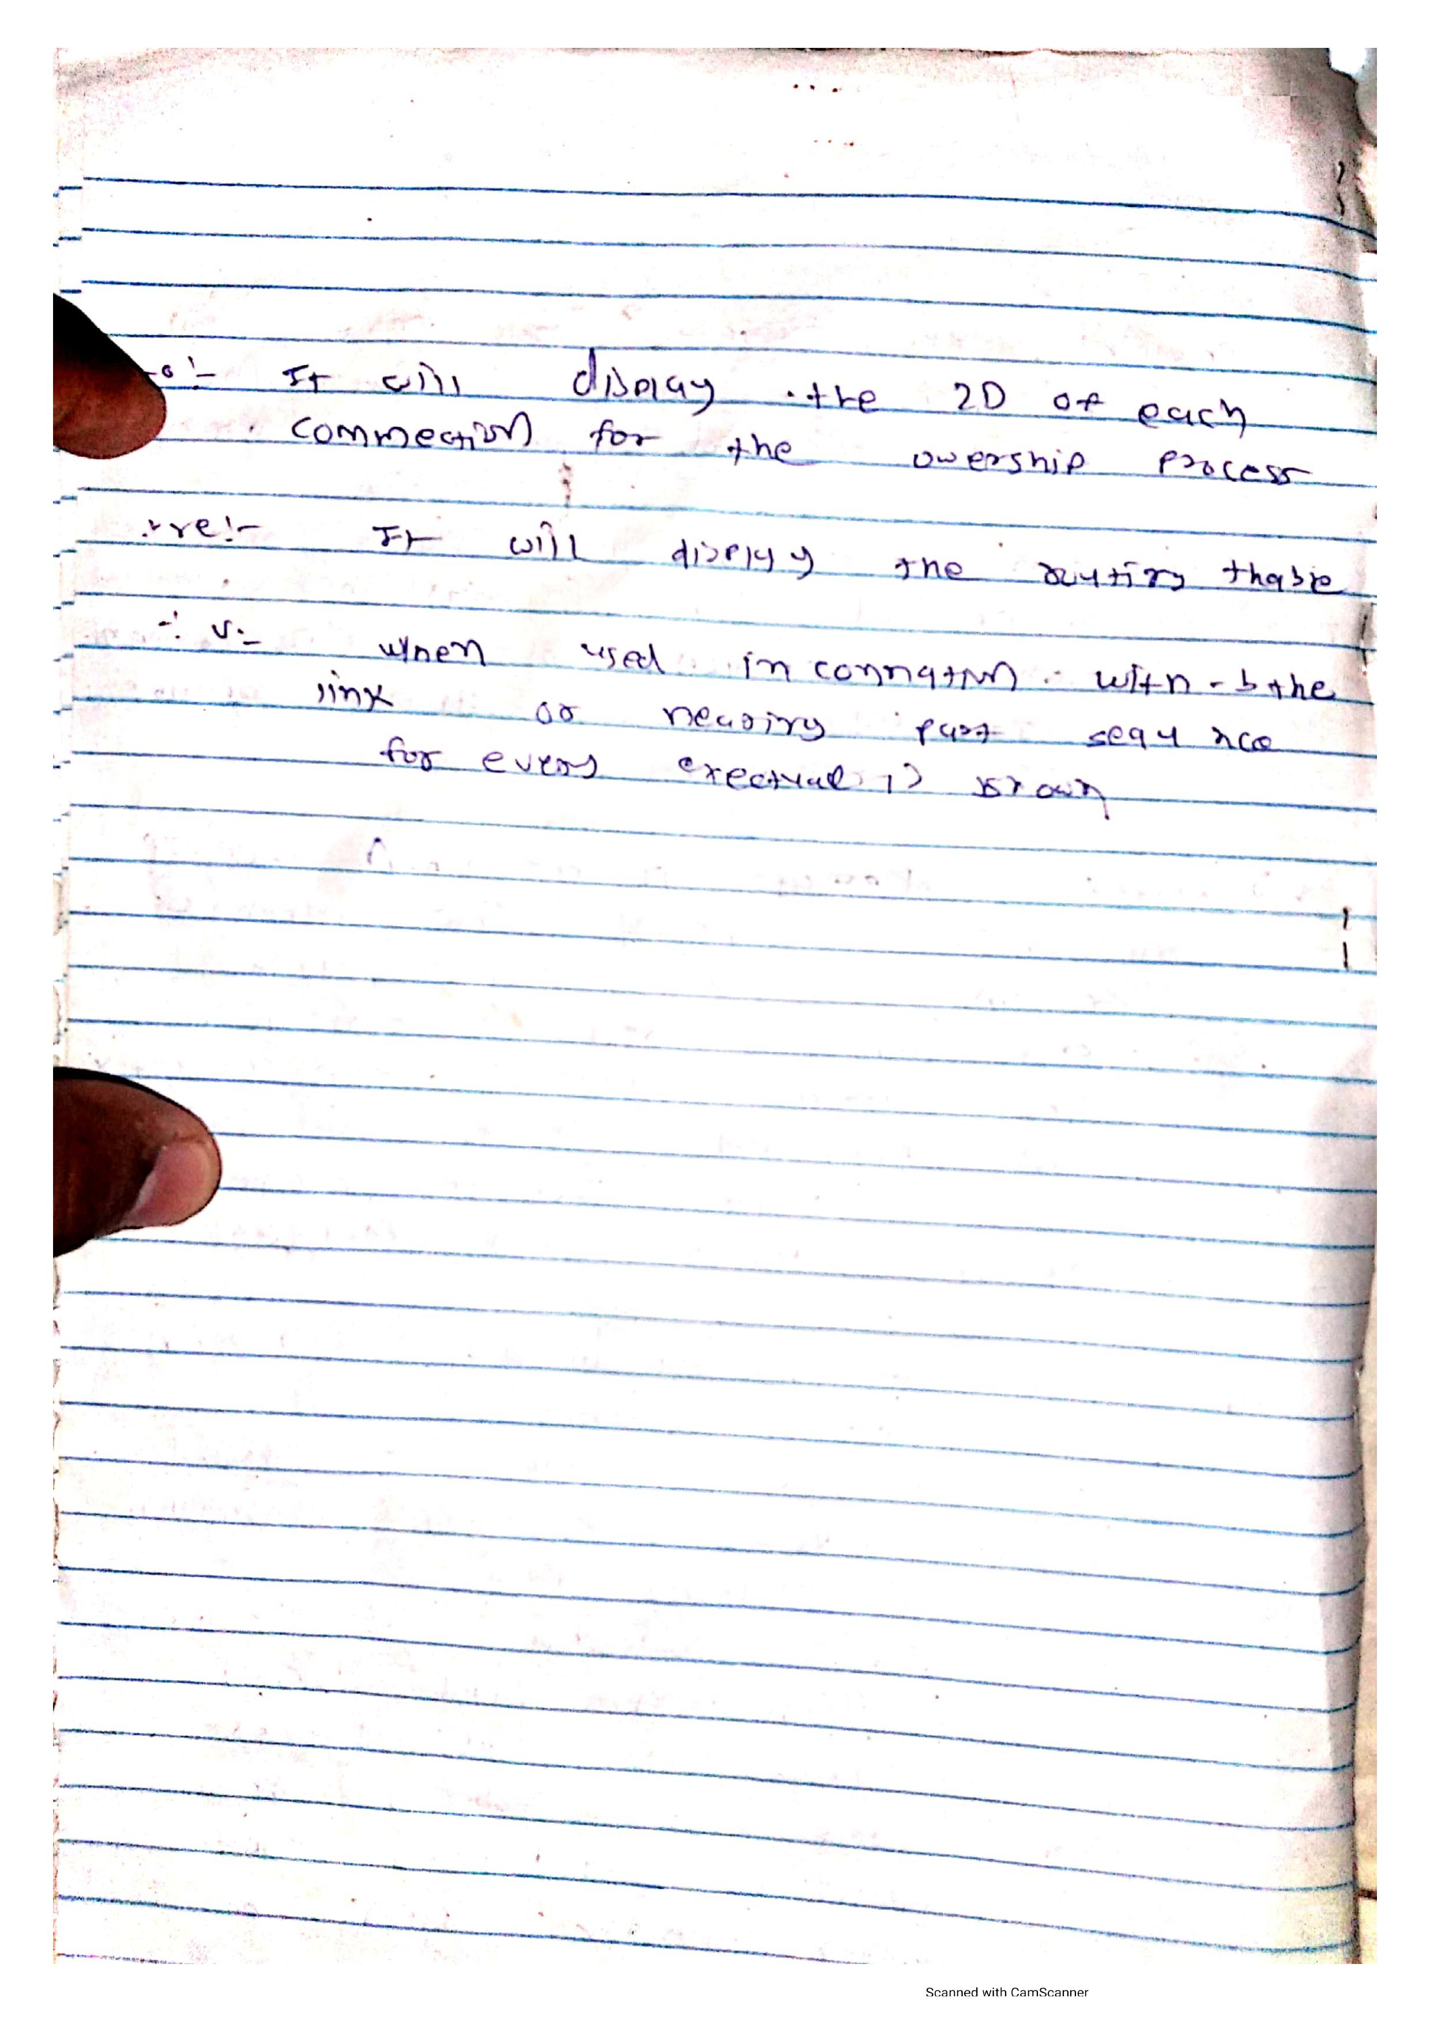

**Practical-3: Implement basic Client Server Socket program for daytime server and daytime client in C or Python.**

## Server side :-

import socket

server_socket=socket.socket(socket.AF_INET,socket.SOCK_STREAM)

server_socket.bind(('127.0.0.1',12345)) server_socket.listen(5)

# 5 (backlog parameter) 5 connection keep waiting if server busy # if 6th connetion tried to connect then it refuse to connect print("enrollment: 190130107041")

print("name : Niraj Italiya") print("CE 5th sem ") print("div : A2 ") print("practical : 03")

print("basic client server program ") while True:

print('server is waiting for connection ') client_socket,addr=server_socket.accept() print('client is connected from ',addr)

while True: data=client_socket.recv(1024)

if not data or data.decode('utf-8')=='END': break

print('recieved from client : %s'%data.decode("utf-8")) try:

# print("")

client_socket.send(bytes("hey client",'utf-8')) except:

print("exited by user") client_socket.close()

server_socket.close()

**Output :-**

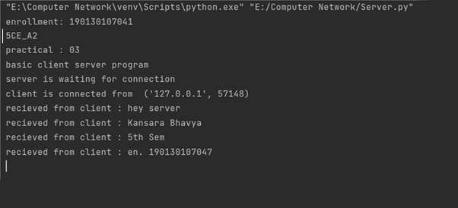

**Client side :-**

import socket

client_socket=socket.socket(socket.AF_INET,socket.SOCK_STREAM) client_socket.connect(('127.0.0.1',12345))

payload="hey server"

try:

while True:

client_socket.send(payload.encode("utf-8"))

data=client_socket.recv(1024) print(str(data))

more=input("want to send more ??: y/n :")

if more.lower()=='y': payload=input('Enter payload : ')

else:

break

except KeyboardInterrupt:

print("exitedd by error") client_socket.close()

**Output :-**

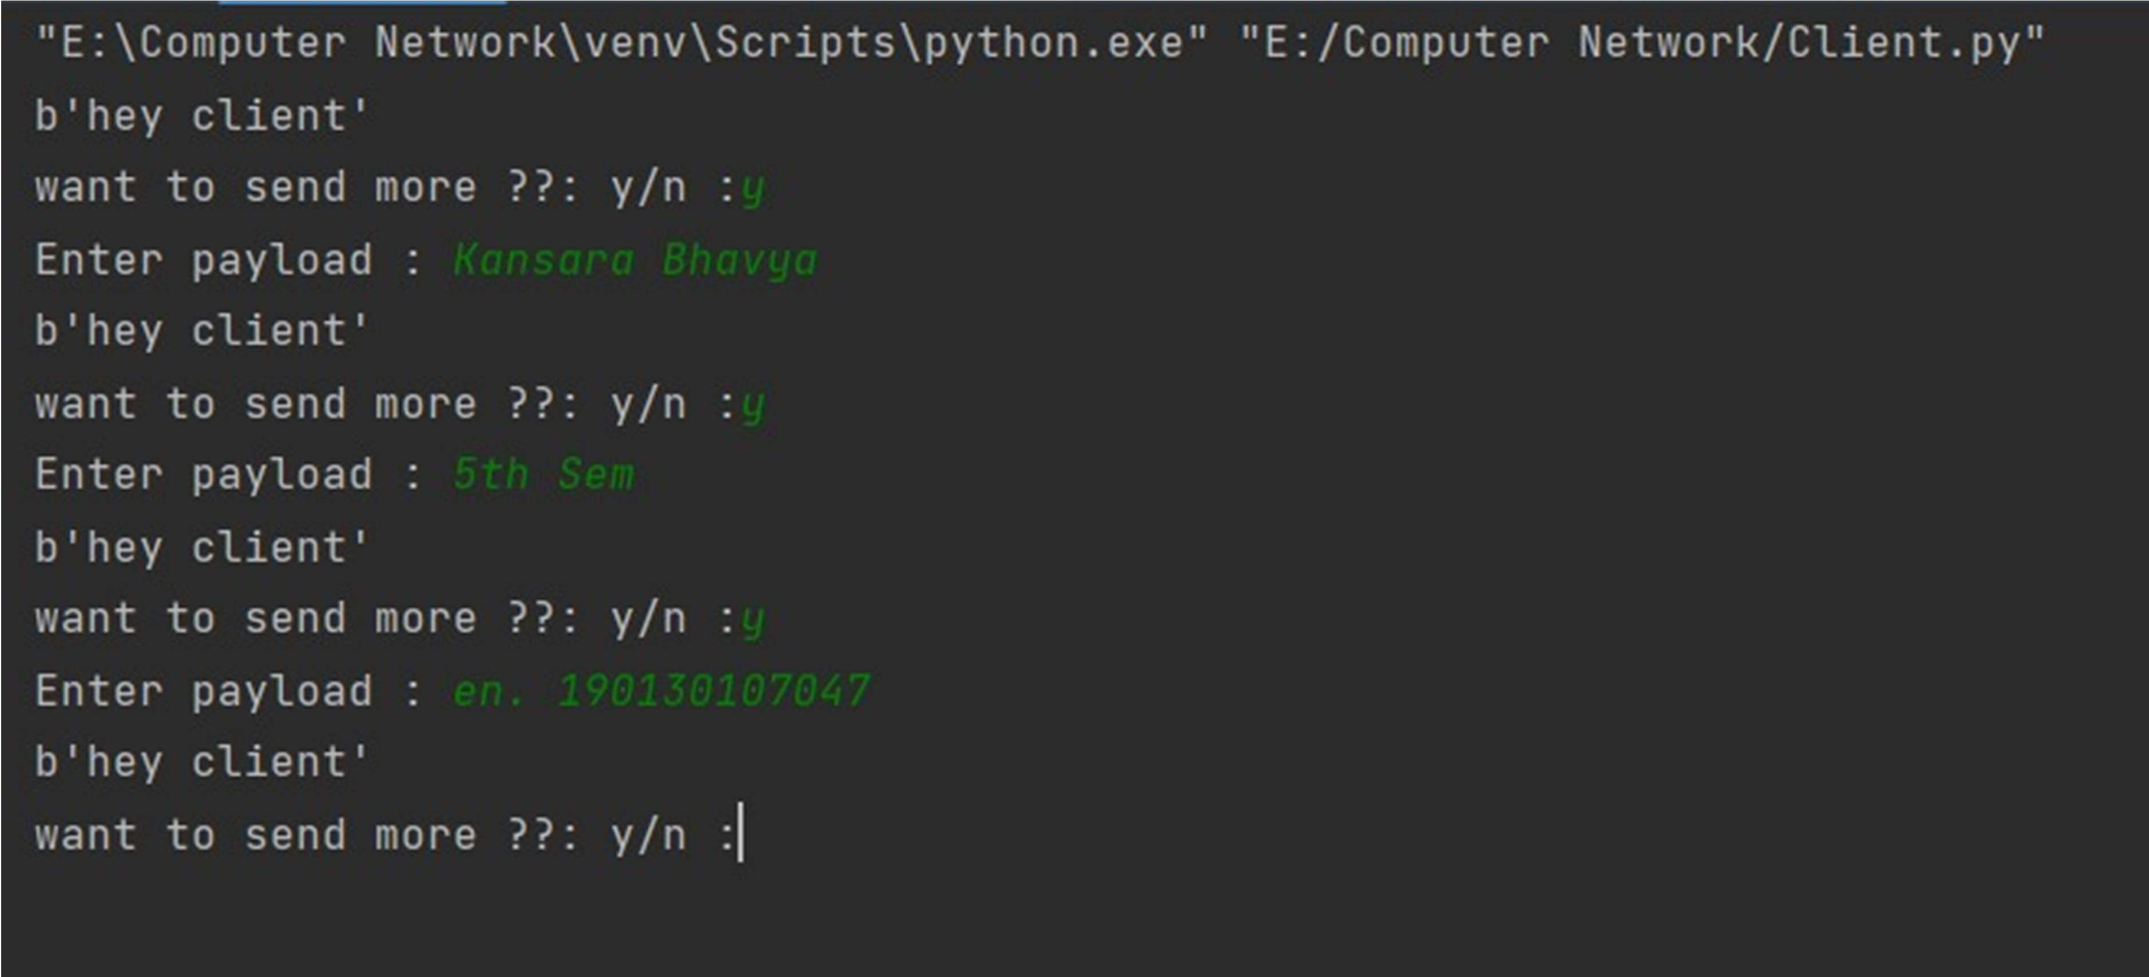

**Practical-4: Implement basic Client Server Socket program for chat server and chat client in C or Python**

**Server side :-**

import time, socket, sys

print("\nWelcome to Chat Room\n") print("Initialising ...\n") time.sleep(1)

s = socket.socket()

host = socket.gethostname()

ip = socket.gethostbyname(host) port = 1234

s.bind((host, port)) print(host, "(", ip, ")\n")

name = input(str("Enter your name: "))

s.listen(1)

print("\nWaiting for incoming connections .. \n") conn, addr = s.accept()

print("Received connection from ", addr[0], "(", addr[1], ")\n")

s_name = conn.recv(1024) s_name = s_name.decode()

print(s_name, "has connected to the chat room\nEnter [e] to exit chat room\n")

conn.send(name.encode())

while True:

message = input(str("Me : ")) if message == "[e]":

message = "Left chat room!" conn.send(message.encode()) print("\n")

break conn.send(message.encode()) message = conn.recv(1024) message = message.decode() print(s_name, ":", message)

**Output :-**

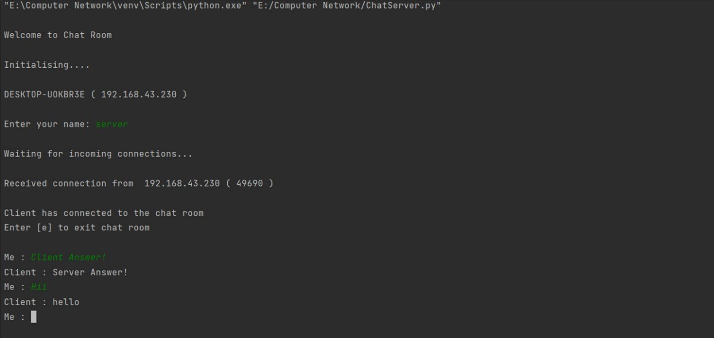

**Client side :-**

import time, socket, sys

print("\nWelcome to Chat Room\n") print("Initialising ... \n") time.sleep(1)

s = socket.socket()

shost = socket.gethostname()

ip = socket.gethostbyname(shost) print(shost, "(", ip, ")\n")

host = input(str("Enter server address: ")) name = input(str("\nEnter your name: ")) port = 1234

print("\nTrying to connect to ", host, "(", port, ")\n") time.sleep(1)

s.connect((host, port))

print("Connected...\n")

s.send(name.encode()) s_name = s.recv(1024) s_name = s_name.decode()

print(s_name, "has joined the chat room\nEnter [e] to exit chat room\n")

while True:

message = s.recv(1024) message = message.decode() print(s_name, ":", message) message = input(str("Me : ")) if message == "[e]":

message = "Left chat room!" s.send(message.encode()) print("\n")

break s.send(message.encode())

**Output :-**

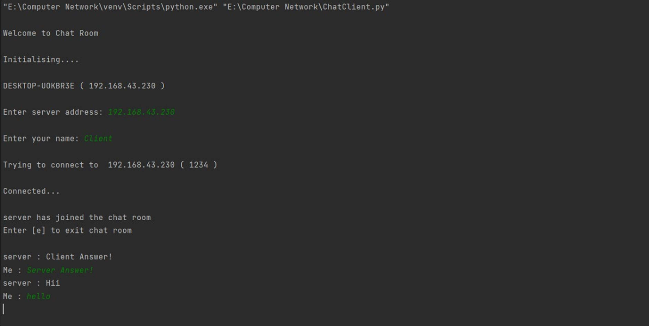

# Practical-5: Create Mesh, ring, bus, star and tree topology in packet tracer and assign appropriate IP addresses to devices. Describe complete configuration procedure.

## Mesh topology:-

Ameshnetworkisalocalnetworktopologyinwhichtheinfrastructurenodes connect directly, dynamically and non-hierarchically to as many other nodes as possible and cooperate with one another to efficiently route data from/to clients

Characteristics of meshtopology:

In a mesh topology, each node has a dedicated point–to–point connection with the rest of the nodes in the network. Dedicated connection means datacan only be flown between two nodes.

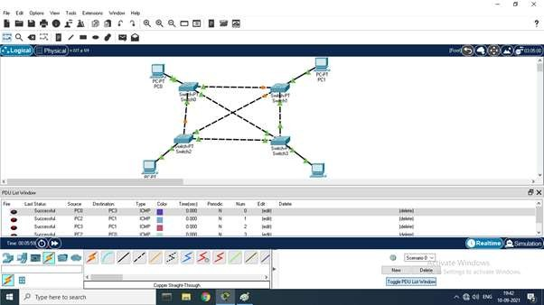

Advantages of MeshTopology:

* Failure during a single device won’t break the network.
* There is no traffic problem as there is a dedicated point to point links for every computer.
* Fault identification is straightforward.
* This topology provides multiple paths to succeed in the destination and

tons of redundancy.

* It provides high privacy and security.
* Data transmission is more consistent because failure doesn’t disrupt its

processes.

* Adding new devices won’t disrupt data transmissions.
* This topology has robust features to beat any situation.
* A mesh doesn’t have a centralized authority.

Disadvantages of Mesh Topology :

* It’s costly as compared to the opposite network topologies i.e. star, bus,

point to point topology.

* Installation is extremely difficult in the mesh.
* Powerrequirement is higher as all the nodeswillneedto remain activeall the time and share the load.
* Complex process.
* The cost to implement mesh is above other selections.
* There is a high risk of redundant connections.
* Each node requires a further utility cost to think about.
* Maintenance needs are challenging with a mesh.

## Ring topology:-

A ring network isa networktopologyinwhich eachnode connectsto exactly two other nodes, forming a single continuous pathway for signals through each node – a ring. Data travels from node to node, with each node along the way handling every packet.

Characteristics of ringtopology:

In a ring topology, each node has a dedicated point–to–point line configuration with the two nodes on either side of it. A signal is passed along the ring in one direction, fromnodetonode, untilit reachesitsreceiver. Eachnode inthering is integrated as a repeater.

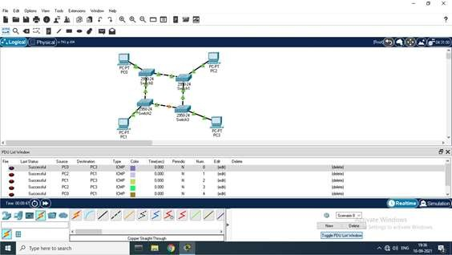

## Advantages of Ring Topology:

* In this data flows inone direction whichreduces the chanceofpacket collisions.
* In this topology additionalworkstationscan beaddedafterwithout impacting performance of the network.
* Equal access to the resources.
* There isno need of server to control the connectivity among the nodes in the topology.
* It is cheap to install and expand.
* Minimum collision.
* Speed to transfer the data is very high in this type of topology.
* Due to the presence of token passing the performance of ring topology

becomes better than bus topology under heavy traffic.

* Easy to manage.
* Ring network is extremely orderly organized where every device has access

to the token and therefore the opportunity to transmit.

**Disadvantages of Ring Topology:**

* Due to the Uni-directional Ring, a data packet (token) must have to pass

through all the nodes.

* If one workstation shuts down, it affects whole network or if a node goes down entire network goes down.
* It is slower in performance as compared to the bus topology
* It is Expensive.
* Addition and removal of any node during a network is difficult andmay cause issue in network activity.
* Difficult to troubleshoot the ring.
* In order for all the computer to communicate with each other, all computer must be turned on.
* Total dependence in on one cable.
* They were not Scalable.

## Bus topology:-

A bus network is a network topology in which nodes are directly connected to a common half-duplex link called a bus. A host on a bus network is called a station. In a bus network, every station will receive all network traffic, and the traffic generated by each station has equal transmission priority.

Characteristics of bustopology:

In a bus topology, all nodes or devices are linked with one transmitter or server computer viaasingle cable(mostly coaxial cable) called backbone. All nodes are connected to the bus cable by drop lines. A drop line is a connection running between the nodes and the main cable.

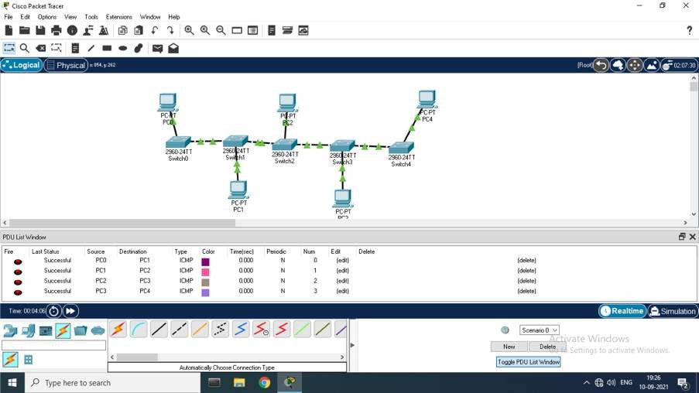

Advantages of BusTopology:

* It is the easiest network topology for connecting peripherals or computers

in a linear fashion.

* It works very efficient well when there is a small network.
* Length of cable required is less than a star topology.
* It is easy to connector remove devices in this network without affecting any other device.
* Very cost-effective as compared to other network topology i.e. mesh and

star

* It is easy to understand topology.
* Easy to expand by joining the two cables together.

Disadvantages of Bus Topology:

* Bus topology is not great for large networks.
* Identification of problem becomes difficult if whole network goes down.
* Troubleshooting of individual device issues is very hard.
* Need of terminators are required at both ends of main cable.
* Additional devices slow network down.
* If a main cable is damaged, whole network fails or splits into two.
* Packet loss is high.
* This network topology is very slow as compared to other topologies.

## Star topology:-

A star network isan implementation ofa spoke–hub distribution paradigm in computer networks. In a star network, every host is connected to a central hub. In its simplest form, one central hub acts as a conduit to transmit messages. The star network is one of the most common computer network topologies.

Characteristics ofstar topology

1. Star topology is more efficients compared to bus topology.
2. In star topology it is easy to diagnos the fault in the star network.
3. Star topology is easy to install.
4. It becomes easy to expand depending on the specification of the central switch

or hub.

1. Star topology requires more cable compared to bus topology.

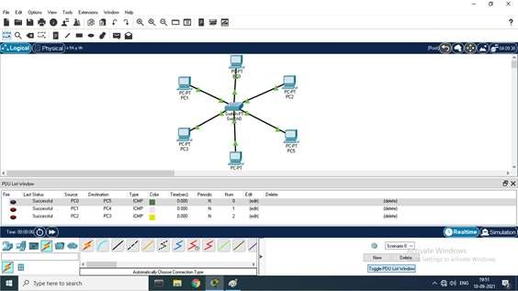

Advantages of Star Topology

* + It is very reliable – if one cable or device fails then all the others will still work
  + It is high-performing as no data collisions can occur
  + Less expensive because each device only need one I/O port and wishes to

be connected with hub with one link.

* + Easier to put in
  + Robust in nature
  + Easy fault detection because the link are often easily identified.
  + No disruptions to the network when connecting or removing devices.
  + Each device requires just one port i.e. to attach to the hub.
  + If N devices are connected to every other in star, then the amount ofcables required to attach them is N. So, it’s easy to line up.

Disadvantages of Star Topology

* + Requires more cable than a linear bus .
  + If the connecting network device (network switch) fails, nodes attached are

disabled and can’t participate in network communication.

* + More expensive than linear bus topology due to the value of the connecting devices (network switches)
  + If hub goes down everything goes down, none of the devices can work

without hub.

* + Hub requires more resources and regular maintenance because it’s the

central system of star.

* + Extra hardware is required (hubs or switches) which adds to cost
  + Performance is predicated on the one concentrator i.e. hub.

## Tree topology:-

A tree network, or star-bus network, is a hybrid network topology in which star networks are interconnected via bus networks. Tree networks are hierarchical, and each node can have an arbitrary number of child nodes.

Characteristics of TreeTopology

* Ideal if nodes are located in groups.
* Used in Wide Area Network.
* Better Flexibility
* Better Scalability

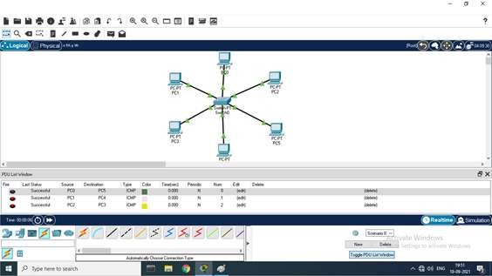

Advantages of TreeTopology:

* + This topology is the combination of bus and star topology.
  + This topology provides a hierarchical as well as central data arrangement of

the nodes.

* + Asthe leafnodescanaddoneormorenodes in thehierarchicalchain, this topology provides high scalability.
  + The other nodes in a network are not affected, if one of their nodes get damaged or not working.
  + Tree topology provides easy maintenance and easy fault identification can

be done.

* + A callable topology. Leaf nodes can hold more nodes.
  + Supported by several hardware and software vendors.
  + Point-to-point wiring for individual segments.

Disadvantagesof Tree Topology:

* + This network is very difficult to configure as compared to the other network topologies.
  + Length of a segment is limited & the limit of the segment depends on the type of cabling used.
  + Duetothepresenceoflargenumberofnodes, thenetwork performance of tree topology becomes a bit slowly.
  + If the computer in first level is erroneous, next level computer will also go under problems.
  + Requires large number of cables compared to star and ring topology.
  + Asthe data needstotravelfromthecentralcablethiscreatesdense network traffic.
  + The Backboneappearsasthefailurepointof theentiresegmentofthe network.
  + Treatment of the topology is pretty complex.
  + The establishment cost increases as well.
  + If the bulk of nodes are added in this network, then the maintenance will become complicated.

Practical-6: Create a sub network using two switches, eight computersandconnectbothsubnetworkusingrouterin packet tracer and assign appropriate IP addresses to devices.

Describe complete configuration procedure..

In this practical we have to merge two networks using router.

First we will put all the required network devices and end devices in the working

area.

After arranging these devices and we’ll connect these devices with the straight

through cable.

After connecting these devices we will give the ip addresses to the end devices. By doing these we can send packets to the same networks but we cannot send

those packets to another network and for that we have to set the configurations of the ROUTER.

For the configuration of the router we will have to write a code of few lines and in the CLI section of router we will change the state of the endpoints of the router to UP.

By doing these we can send messages to one network to another network.

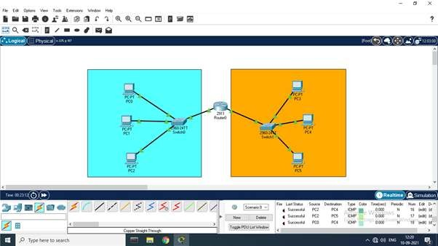

# Practical-7:- Create a network topology with four host machines, local and authoritative DNS server and web server. Describe complete configuration procedure.

A DNS server is a computer server that contains a database of public IP addresses and their associated hostnames, and in most cases serves to resolve, or translate, those names to IP addresses as requested. DNS servers run special software and communicate with each other using special protocols.





This is the command prompt view of the dns server.

When you write a domain name it gives you the IP address of it.



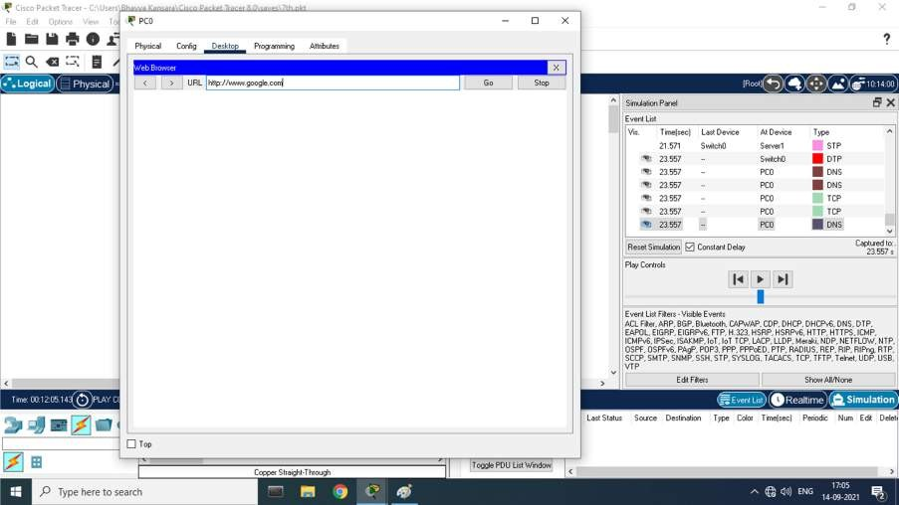



This is the final product of the dns server where it is simulating.

# Practical-8:- Implement the concept of dynamic routing using Network Simulator

Dynamic routing, also called adaptive routing, is a process where a router can forward data via a different route or given destination based on the current conditions of the communication circuits within a system. Dynamic routing allows as many routes as possible to remain valid in response to the change.

### RIP (Routing Information Protocol)

Unlike the other routing protocols, there are actually two different versions of RIP. The original RIP v1/2 protocol handles IPv4 routing. RIPng as the next generation, however, supports IPv6. Each is configured independently.

It is commonly assumed that RIP is no longer appropriate as a routing protocol, primarily due to its behaviour of frequently sending the entire local forward database to all peers. However, there are still architectures where it is appropriate. It is particularly appropriate in architectures that require dynamic routing support but also a very fast convergence time. For example, consider a distributed IPsec hub-and-spoke topology that leverages dialup as well as redundant tunnel configurations.

This is the direct connection of three routers.



This is the complex configuration which is actually more of an easy way. Where if you want to transfer the packets from PC1 to PC4 you particularly don’t need the initial connection.



This is the real time result of dynamic routing.



# Practical-9:- Implement the concept of VLAN using Network Simulator.



**Practical-10:- Packet capture and header analysis by wire-shark (TCP, UDP, IP)**

